Functions in SQL server can be broadly divided into 2 categoris  
**1.** Built-in functions  
**2.** User Defined functions  
  
There are several built-in functions. In this video session, we will look at the most common string functions available.  
  
   
  
   
  
   
  
ASCII(Character_Expression) - Returns the ASCII code of the given character expression.  
To find the ACII Code of capital letter 'A'  
 **Example:** Select ASCII('A')  
**Output:** 65  
  
CHAR(Integer_Expression) - Converts an int ASCII code to a character. The Integer_Expression, should be between 0 and 255.  
The following SQL, prints all the characters for the ASCII values from o thru 255  
  
Declare @Number int  
Set @Number = 1  
While(@Number <= 255)  
Begin  
 Print CHAR(@Number)  
 Set @Number = @Number + 1  
End  
  
**Note:** The while loop will become an infinite loop, if you forget to include the following line.  
Set @Number = @Number + 1  
  
**Printing uppercase alphabets using CHAR() function:**  
Declare @Number int  
Set @Number = 65  
While(@Number <= 90)  
Begin  
 Print CHAR(@Number)  
 Set @Number = @Number + 1  
End  
  
**Printing lowercase alphabets using CHAR() function:**  
Declare @Number int  
Set @Number = 97  
While(@Number <= 122)  
Begin  
 Print CHAR(@Number)  
 Set @Number = @Number + 1  
End  
  
  
**Another way of printing lower case alphabets using CHAR() and LOWER() functions.**  
Declare @Number int  
Set @Number = 65  
While(@Number <= 90)  
Begin  
 Print LOWER(CHAR(@Number))  
 Set @Number = @Number + 1  
End  
  
LTRIM(Character_Expression) - Removes blanks on the left handside of the given character expression.  
  
**Example**: Removing the 3 white spaces on the left hand side of the '   Hello' string using LTRIM() function.  
Select LTRIM('   Hello')  
**Output**: Hello  
  
RTRIM(Character_Expression) - Removes blanks on the right hand side of the given character expression.  
 **Example**: Removing the 3 white spaces on the left hand side of the 'Hello   ' string using RTRIM() function.  
Select RTRIM('Hello   ')  
**Output**: Hello  
  
**Example**: To remove white spaces on either sides of the given character expression, use LTRIM() and RTRIM() as shown below.  
Select LTRIM(RTRIM('   Hello   '))  
**Output**: Hello  
  
LOWER(Character_Expression) - Converts all the characters in the given Character_Expression, to lowercase letters.  
  
**Example**: Select LOWER('CONVERT This String Into Lower Case')  
**Output**: convert this string into lower case  
  
UPPER(Character_Expression) - Converts all the characters in the given Character_Expression, to uppercase letters.  
**Example**: Select UPPER('CONVERT This String Into upper Case')  
**Output**: CONVERT THIS STRING INTO UPPER CASE  
  
REVERSE('Any_String_Expression') - Reverses all the characters in the given string expression.  
**Example**: Select REVERSE('ABCDEFGHIJKLMNOPQRSTUVWXYZ')  
**Output**: ZYXWVUTSRQPONMLKJIHGFEDCBA  
  
LEN(String_Expression) - Returns the count of total characters, in the given string expression, excluding the blanks at the end of the expression.  
  
**Example**: Select LEN('SQL Functions   ')  
**Output**: 13  
  
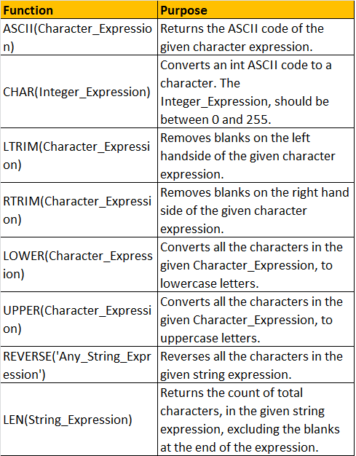   
  
In the next video session, we will discuss about the rest of the commonly used built-in string functions.